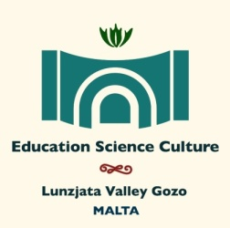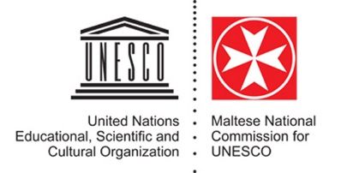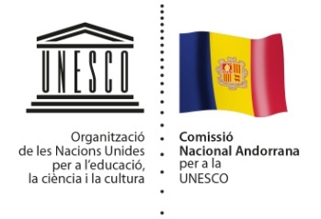

**The Secretary General,**

**National Commission for UNESCO**

Dear Sir/Madam

**ART CAMP MALTA – 2019**

The Maltese National Commission for UNESCO and UNESCO’s Associated Schools National Coordination, in collaboration with the Andorran National Commission for UNESCO are happy to announce that the third edition of Art Camp Malta will be held between the 24th October and the 5th of November 2019.

As you are probably well aware, the aim of this project created some years ago by the Andorra National Commission for UNESCO is not only to create a showcase of original and truly creative works of art, but also to reinforce the principal values embraced by UNESCO i.e. the sustainability of Peace and the protection and promotion of the Diversity of Cultural Expression. This will be emphasised throughout a varied programme of events and by a joint manifesto which will be signed by all the participants at the end of this celebration of art.

As Madame Hedva Ser, UNESCO Goodwill Ambassador and Special Envoy for Cultural Diplomacy, rightfully referred to Art Camp: ”*Art Camp is a laboratory of Peace, a bridge of hope reaching out to other cultures*”.

The first edition of Art Camp which was held on the Islands of Malta and Gozo in October 2015 was a successful event, which saw the participation of over 15 artists from as many countries. The Second edition was held on the Island of Gozo in May 2017 and participation increased to 23 artists from the same number countries.

For 2019, we would like to build on these achievements and we are therefore opening the for call nominations for participation in this event. In this regard we take this opportunity to forward you our formal invitation and welcome your country’s participation through the nomination of a suitable candidate to participate as the Art ambassador of your country. We kindly ask you to send in the nomination of the chosen artist along with his/her *curriculum vitae* by no later than **15th August 2019**, as this would allow us enough time to organise the necessary logistics for the event.

Art Camp 2019 which will be held again on the beautiful Island of Gozo, will once again be patronised by UNESCO’s Artist Ambassador for Peace Mme. Hedva Ser as godmother. Art Camp will be spread over a period of ten days and as for participation costs, participating artists will only be asked to pay their travelling costs to and from Malta. All other expenses will be borne by the organisation handling the event. A full programme will be forwarded in July. Malta forms part of the Schengen area, and nationals from non-EU countries should enquire with their respective embassies to member countries on the requirement or otherwise of a visa to enter and leave the Schengen area.

The participation of your country in this event is solicited as a strong participation will ensure that UNESCO’s efforts towards *the International Decade for the Rapprochement of Cultures (2013-2022)* are successful.

We are herewith attaching an application form which is to be filled in by the artist nominated by your National Commission and forwarded to us at *:* [*philip.a.cassar@gov.mt*](mailto:philip.a.cassar@gov.mt)and[*matthew.sultana@gov.mt*](mailto:matthew.sultana@gov.mt)*.* Kindly note that participation is restricted to 20 artists.

If you have any queries or require further information you may forward these to the above email addresses.

Thank you for your cooperation and hope to see you in Malta (Gozo) in October.

Best regards,

*Philip Cassar*

*Executive Secretary*

